Program 10: Develop a Web page(s) with suitable HTML elements to demonstrate Bootstrap 5.0 framework classes for Modals, Alerts and Popover.

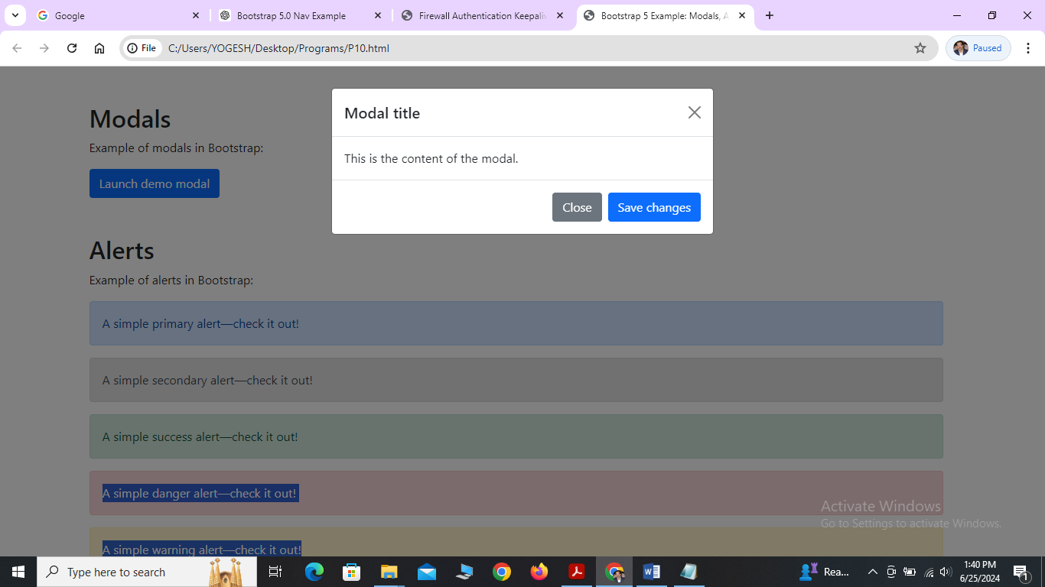

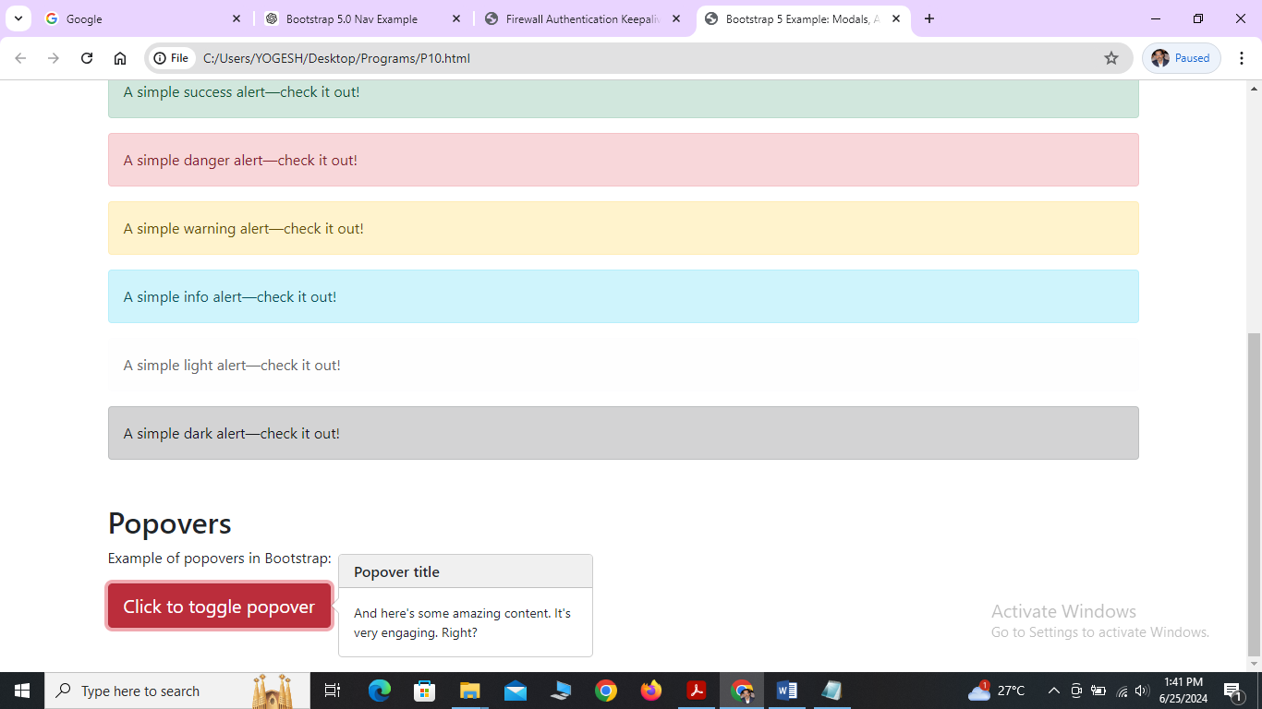

Program:

<!DOCTYPE html>

<html lang="en">

<head>

<meta charset="UTF-8">

<meta name="viewport" content="width=device-width, initial-scale=1.0">

<title>Bootstrap 5 Example: Modals, Alerts, and Popovers</title>

<link href="https://cdn.jsdelivr.net/npm/bootstrap@5.0.2/dist/css/bootstrap.min.css" rel="stylesheet">

<script src="https://cdn.jsdelivr.net/npm/@popperjs/core@2.9.2/dist/umd/popper.min.js"></script>

<script src="https://cdn.jsdelivr.net/npm/bootstrap@5.0.2/dist/js/bootstrap.min.js"></script>

</head>

<body>

<!-- Modals -->

<div class="container mt-5">

<h2>Modals</h2>

<p>Example of modals in Bootstrap:</p>

<!-- Button trigger modal -->

<button type="button" class="btn btn-primary" data-bs-toggle="modal" data-bs-target="#exampleModal">

Launch demo modal

</button>

<!-- Modal -->

<div class="modal fade" id="exampleModal" tabindex="-1" aria-labelledby="exampleModalLabel" aria-hidden="true">

<div class="modal-dialog">

<div class="modal-content">

<div class="modal-header">

<h5 class="modal-title" id="exampleModalLabel">Modal title</h5>

<button type="button" class="btn-close" data-bs-dismiss="modal" aria-label="Close"></button>

</div>

<div class="modal-body">

This is the content of the modal.

</div>

<div class="modal-footer">

<button type="button" class="btn btn-secondary" data-bs-dismiss="modal">Close</button>

<button type="button" class="btn btn-primary">Save changes</button>

</div>

</div>

</div>

</div>

</div>

<!-- Alerts -->

<div class="container mt-5">

<h2>Alerts</h2>

<p>Example of alerts in Bootstrap:</p>

<div class="alert alert-primary" role="alert">

A simple primary alert—check it out!

</div>

<div class="alert alert-secondary" role="alert">

A simple secondary alert—check it out!

</div>

<div class="alert alert-success" role="alert">

A simple success alert—check it out!

</div>

<div class="alert alert-danger" role="alert">

A simple danger alert—check it out!

</div>

<div class="alert alert-warning" role="alert">

A simple warning alert—check it out!

</div>

<div class="alert alert-info" role="alert">

A simple info alert—check it out!

</div>

<div class="alert alert-light" role="alert">

A simple light alert—check it out!

</div>

<div class="alert alert-dark" role="alert">

A simple dark alert—check it out!

</div>

</div>

<!-- Popovers -->

<div class="container mt-5 mb-5">

<h2>Popovers</h2>

<p>Example of popovers in Bootstrap:</p>

<button type="button" class="btn btn-lg btn-danger" data-bs-toggle="popover" title="Popover title" data-bs-content="And here's some amazing content. It's very engaging. Right?">

Click to toggle popover

</button>

</div>

<script>

// Initialize popovers

var popoverTriggerList = [].slice.call(document.querySelectorAll('[data-bs-toggle="popover"]'))

var popoverList = popoverTriggerList.map(function (popoverTriggerEl) {

return new bootstrap.Popover(popoverTriggerEl)

})

</script>

</body>

</html>

Explanation:

**Head Section**

1. **Meta Tags and Title**:
   * <meta charset="UTF-8">: Sets the character encoding to UTF-8.
   * <meta name="viewport" content="width=device-width, initial-scale=1.0">: Ensures proper scaling on mobile devices.
   * <title>Bootstrap 5 Example: Modals, Alerts, and Popovers</title>: Sets the title of the webpage.
2. **Bootstrap CSS and JS**:
   * <link href="https://cdn.jsdelivr.net/npm/bootstrap@5.0.2/dist/css/bootstrap.min.css" rel="stylesheet">: Includes Bootstrap 5 CSS from a CDN.
   * <script src="https://cdn.jsdelivr.net/npm/@popperjs/core@2.9.2/dist/umd/popper.min.js"></script>: Includes Popper.js, a required dependency for Bootstrap components.
   * <script src="https://cdn.jsdelivr.net/npm/bootstrap@5.0.2/dist/js/bootstrap.min.js"></script>: Includes Bootstrap 5 JavaScript from a CDN.

#### Body Section

##### Modals

**Modals**: A dialog window that appears on top of the webpage content.

* **Button to Trigger Modal**:
  + <button type="button" class="btn btn-primary" data-bs-toggle="modal" data-bs-target="#exampleModal">Launch demo modal</button>: A button that when clicked triggers the modal with id="exampleModal".
* **Modal Structure**:
  + <div class="modal fade" id="exampleModal" tabindex="-1" aria-labelledby="exampleModalLabel" aria-hidden="true">: The modal container.
  + <div class="modal-dialog">: The modal dialog.
  + <div class="modal-content">: The modal content.
  + **Modal Header**:
    - <div class="modal-header">: Contains the modal title and close button.
    - <h5 class="modal-title" id="exampleModalLabel">Modal title</h5>: The title of the modal.
      * <button type="button" class="btn-close" data-bs-dismiss="modal" aria-label="Close"></button>: A button to close the modal.
    - **Modal Body**:
      * <div class="modal-body">: The main content of the modal.
    - **Modal Footer**:
      * <div class="modal-footer">: Contains buttons or actions related to the modal.
      * <button type="button" class="btn btn-secondary" data-bs-dismiss="modal">Close</button>: A button to close the modal.
      * <button type="button" class="btn btn-primary">Save changes</button>: A button to save changes within the modal.

##### Alerts

* **Alerts**: Provide contextual feedback messages.
  + <div class="alert alert-primary" role="alert">: Creates a primary alert with blue color.
  + Various classes (alert-secondary, alert-success, alert-danger, etc.) create different colored alerts for different types of messages.

##### Popovers

* **Popovers**: Small overlay content containers for displaying additional information.
  + <button type="button" class="btn btn-lg btn-danger" data-bs-toggle="popover" title="Popover title" data-bs-content="And here's some amazing content. It's very engaging. Right?">: A button that toggles the popover.
  + data-bs-toggle="popover": Attribute that triggers the popover behavior.
  + title="Popover title": Title of the popover.
  + data-bs-content="And here's some amazing content. It's very engaging. Right?": Content of the popover.

**Script Section**

* **Script for Popovers**:
  + Initializes popovers on all elements with data-bs-toggle="popover" attribute.
  + Uses JavaScript to find all elements with data-bs-toggle="popover" and initialize Bootstrap's Popover functionality on them.
  + This script ensures that when a button with popover functionality is clicked, the popover content is displayed as specified.

### Summary

The provided HTML code demonstrates the use of Bootstrap 5.0 classes for modals, alerts, and popovers. Modals are used to display dialog boxes, alerts for contextual feedback messages, and popovers for displaying additional information in an overlay. The use of Bootstrap classes simplifies the creation and styling of these UI components, making them responsive and visually appealing across different devices and screen sizes.